EXPERIMENT 11
Investigation of Overflow Effects and Signal Scaling in Digital Filters Using MATLAB
Date | 12/10/2026
Name and Register Number | Lokesh A (192512293)
Programme | B.E. Electronics and Communication Engineering (ECE)
1. Aim
To investigate overflow, saturation, wrap-around effects, and signal scaling in a digital filter using MATLAB, and to compare the resulting output signals and quantization errors.
2. Objectives
- To implement signed Q1.7 fixed-point quantization.
- To identify overflow conditions in the filter output.
- To compare saturation and wrap-around arithmetic.
- To study the effect of input signal scaling on peak output and overflow.
- To calculate RMSE and compare the output characteristics graphically.
3. MATLAB Program
clc; clear; close all;
%% EXPERIMENT: OVERFLOW, SATURATION, WRAP-AROUND AND SIGNAL SCALING
%% INPUT PARAMETERS
b = [0.0048 0.0193 0.0289 0.0193 0.0048];
a = [1 -2.3695 2.3140 -1.0547 0.1874];
A = 0.9;
f = 50;
Fs = 1000;
N = 200;
B = 8;
SF = 0.5;
n = 0:N-1;
x = A*sin(2*pi*f*n/Fs);
%% Q1.7 FIXED-POINT PARAMETERS
S = 2^(B-1);
QMAX = (S-1)/S;
QMIN = -1;
% Signed Q1.7 quantizer with saturation
q = @(z) min(max(round(z*S)/S,QMIN),QMAX);
%% 1. IDEAL AND QUANTIZED RESPONSE
y = filter(b,a,x);
ys = q(y);
Peak_Unscaled = max(abs(y));
%% 2. OVERFLOW DETECTION
ov = (y < QMIN) | (y > QMAX);
No_Overflow = sum(ov);
%% 3. SATURATION
ysat = q(y);
Peak_Saturation = max(abs(ysat));
%% 4. WRAP-AROUND
yint = round(y*S);
ywrap = (mod(yint + S,2*S)-S)/S;
Peak_Wrap = max(abs(ywrap));
%% 5. SIGNAL SCALING
xs = SF*x;
y_scaled_ideal = filter(b,a,xs);
yscale = q(y_scaled_ideal);
Peak_Scaled = max(abs(yscale));
ov_scaled = (y_scaled_ideal < QMIN) | ...
(y_scaled_ideal > QMAX);
No_Overflow_Scaled = sum(ov_scaled);
%% 6. ERROR CALCULATION
RMSE_Sat = sqrt(mean((y-ysat).^2));
RMSE_Wrap = sqrt(mean((y-ywrap).^2));
RMSE_Scale = sqrt(mean((y_scaled_ideal-yscale).^2));
%% 7. DISPLAY RESULTS
fprintf('\\n========================================\\n');
fprintf(' FIXED-POINT ARITHMETIC RESULTS\\n');
fprintf('========================================\\n');
fprintf('Q1.7 Range: [%.7f, %.7f]\\n',QMIN,QMAX);
fprintf('Quantization Step Size: %.7f\\n',1/S);
fprintf('Unscaled Peak: %.6f\\n',Peak_Unscaled);
fprintf('Overflow Count: %d\\n',No_Overflow);
fprintf('Saturation Peak: %.6f\\n',Peak_Saturation);
fprintf('Wrap-around Peak: %.6f\\n',Peak_Wrap);
fprintf('Scaling Factor: %.2f\\n',SF);
fprintf('Scaled Peak: %.6f\\n',Peak_Scaled);
fprintf('Scaled Overflow Count: %d\\n',No_Overflow_Scaled);
fprintf('Saturation RMSE: %.6e\\n',RMSE_Sat);
fprintf('Wrap-around RMSE: %.6e\\n',RMSE_Wrap);
fprintf('Scaled Output RMSE: %.6e\\n',RMSE_Scale);
%% 8. OUTPUT PARAMETER TABLE
Method = {'Unscaled';'Saturation';'Wrap-around';'Scaled'};
Peak = [Peak_Unscaled;
Peak_Saturation;
Peak_Wrap;
Peak_Scaled];
RMSE = [0;
RMSE_Sat;
RMSE_Wrap;
RMSE_Scale];
Overflow = [No_Overflow;
0;
0;
No_Overflow_Scaled];
T = table(Method,Peak,RMSE,Overflow);
fprintf('\\nOUTPUT PARAMETER TABLE\\n');
disp(T);
%% 9. GRAPH: IDEAL VS SATURATION
figure;
plot(n,y,'k','LineWidth',1.2);
hold on;
plot(n,ysat,'r--','LineWidth',1.2);
grid on;
xlabel('Sample n');
ylabel('Amplitude');
title('Ideal vs Saturation');
legend('Ideal','Saturation','Location','best');
%% 10. GRAPH: IDEAL VS WRAP-AROUND
figure;
plot(n,y,'k','LineWidth',1.2);
hold on;
plot(n,ywrap,'r--','LineWidth',1.2);
grid on;
xlabel('Sample n');
ylabel('Amplitude');
title('Ideal vs Wrap-around');
legend('Ideal','Wrap-around','Location','best');
%% 11. GRAPH: SCALED OUTPUT
figure;
plot(n,y_scaled_ideal,'k','LineWidth',1.2);
hold on;
plot(n,yscale,'r--','LineWidth',1.2);
grid on;
xlabel('Sample n');
ylabel('Amplitude');
title('Scaled Output');
legend('Scaled Ideal','Quantized','Location','best');
%% 12. GRAPH: ERROR COMPARISON
figure;
plot(n,y-ysat,'LineWidth',1.2);
hold on;
plot(n,y-ywrap,'--','LineWidth',1.2);
plot(n,y_scaled_ideal-yscale,':','LineWidth',1.5);
grid on;
xlabel('Sample n');
ylabel('Error');
title('Error Comparison');
legend('Saturation','Wrap-around','Scaling','Location','best');
%% 13. GRAPH: PEAK MAGNITUDE COMPARISON
figure;
bar(Peak);
grid on;
set(gca,'XTick',1:4,'XTickLabel',Method);
xlabel('Method');
ylabel('Peak Magnitude');
title('Peak Magnitude Comparison');
%% 14. FINAL RESULT
fprintf('\\n========================================\\n');
fprintf(' FINAL RESULT\\n');
fprintf('========================================\\n');
fprintf('Q1.7 fixed-point quantization was implemented.\\n');
fprintf('Overflow, saturation and wrap-around were analyzed.\\n');
fprintf('Signal scaling and quantization errors were evaluated.\\n');
fprintf('All five comparison graphs were generated.\\n');
4. Simulation Parameters
Parameter | Value
Numerator coefficients | [0.0048 0.0193 0.0289 0.0193 0.0048]
Denominator coefficients | [1 -2.3695 2.3140 -1.0547 0.1874]
Input amplitude | 0.9
Input frequency | 50 Hz
Sampling frequency | 1000 Hz
Number of samples | 200
Word length | 8 bits
Fixed-point format | Q1.7
Signal scaling factor | 0.5
5. Output Results
Parameter | Observed value
Q1.7 representable range | −1.0000000 to 0.9921875
Quantization step size | 0.0078125
Unscaled peak | 0.901600
Overflow count | 0
Saturation peak | 0.898438
Wrap-around peak | 0.898438
Scaling factor | 0.50
Scaled peak | 0.453125
Scaled overflow count | 0
Saturation RMSE | 2.389472 × 10⁻³
Wrap-around RMSE | 2.389472 × 10⁻³
Scaled output RMSE | 2.219846 × 10⁻³
6. Output Graphs
Figure 1. Ideal vs Saturation
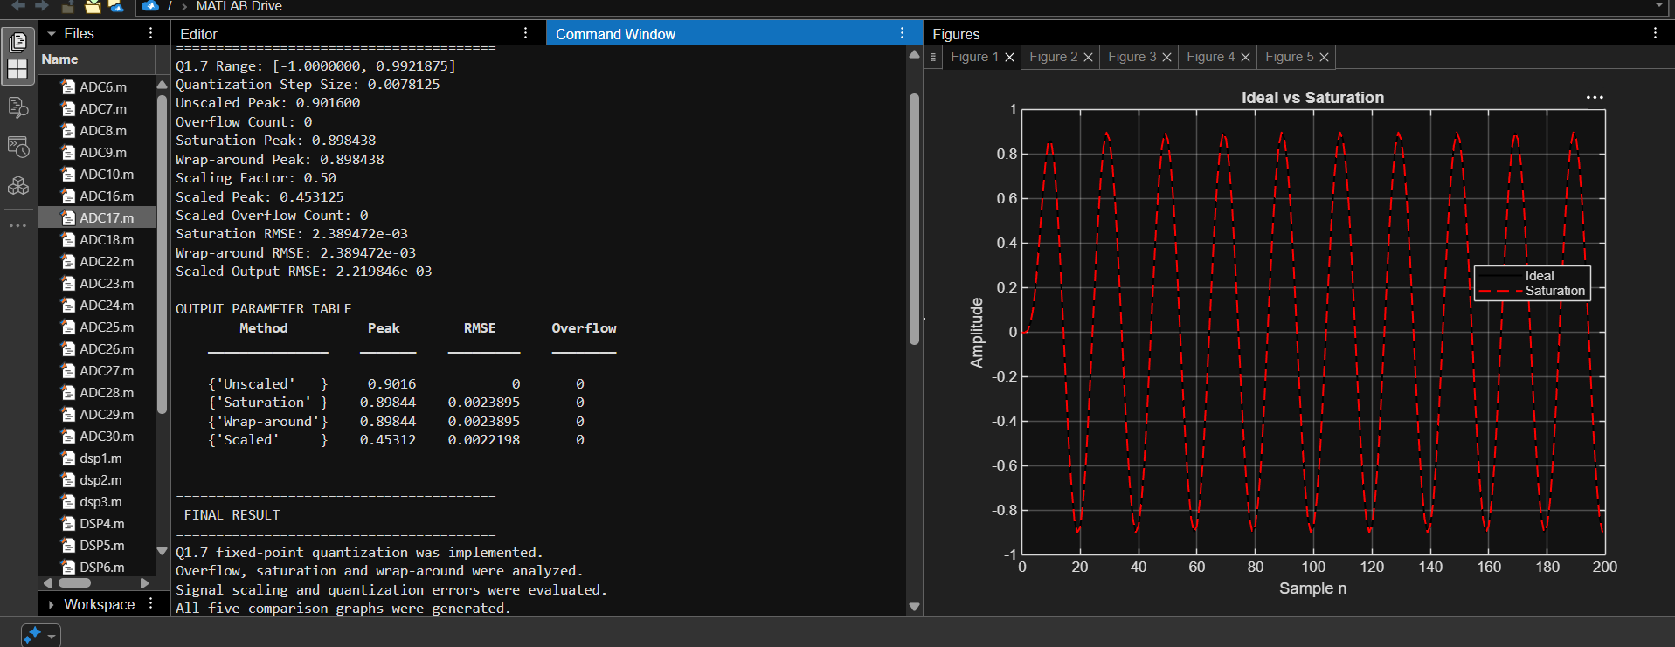
Figure 2. Ideal vs Wrap-around
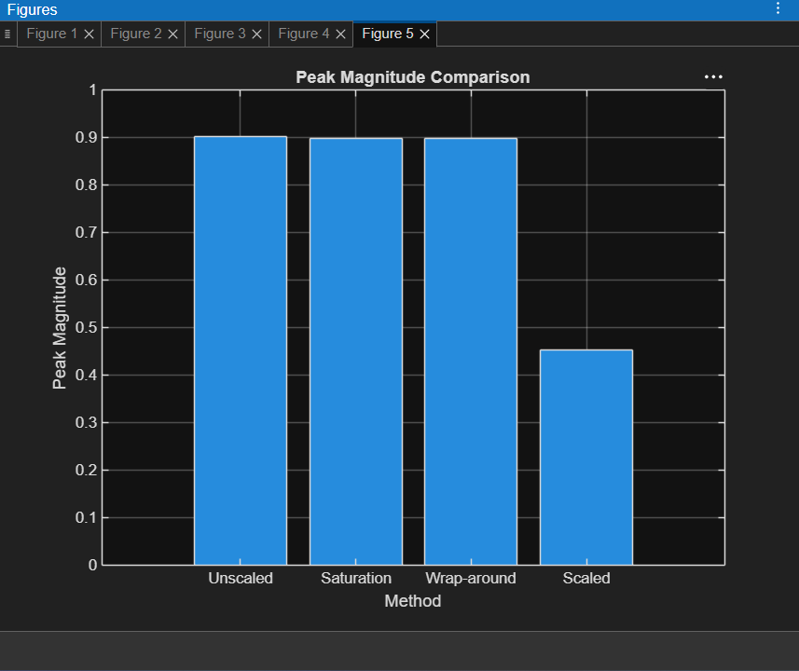
Figure 3. Scaled Output
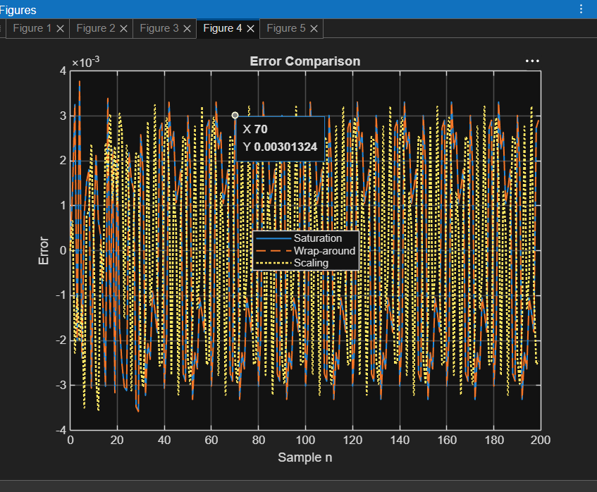
Figure 4. Error Comparison
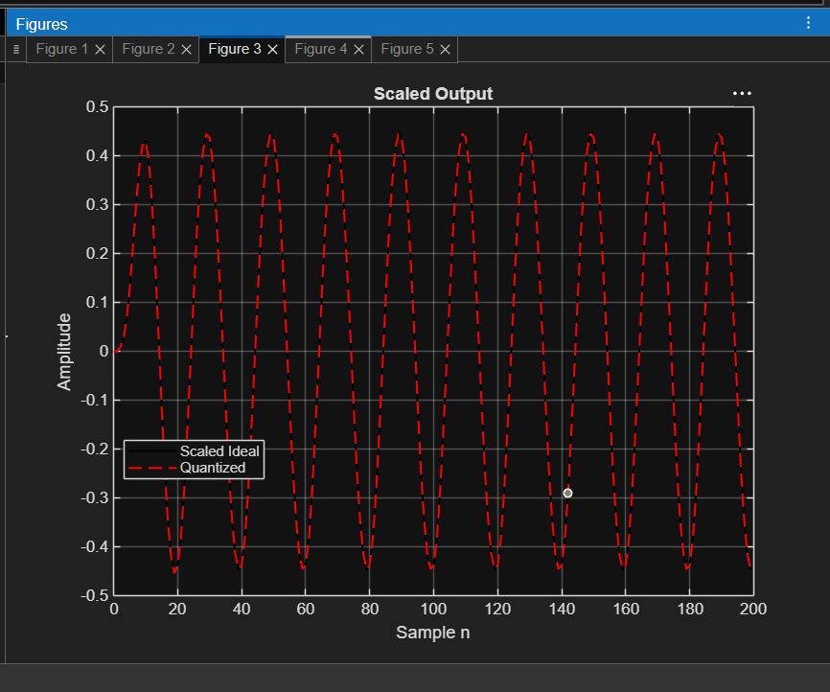
Figure 5. Peak Magnitude Comparison
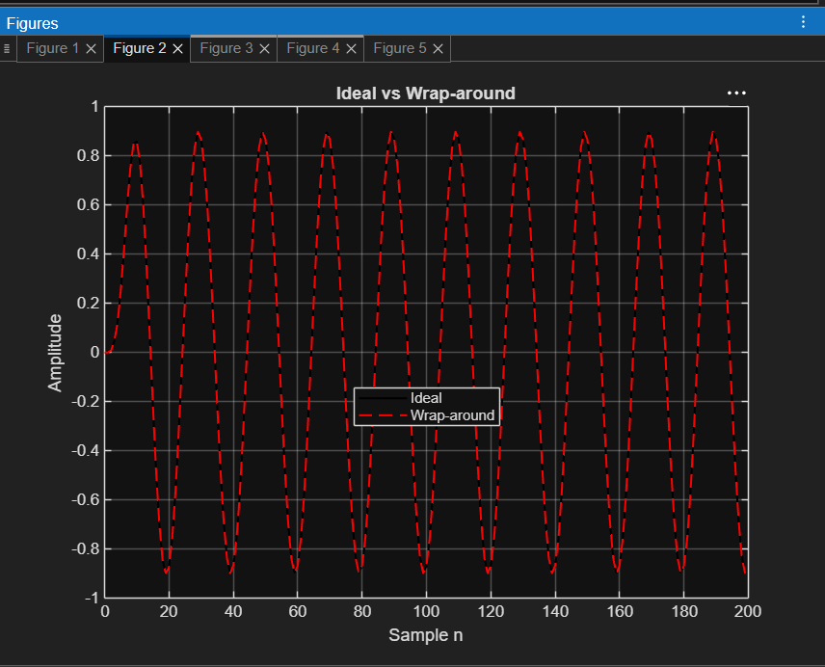
Figure 6. MATLAB Command Window and Output Summary
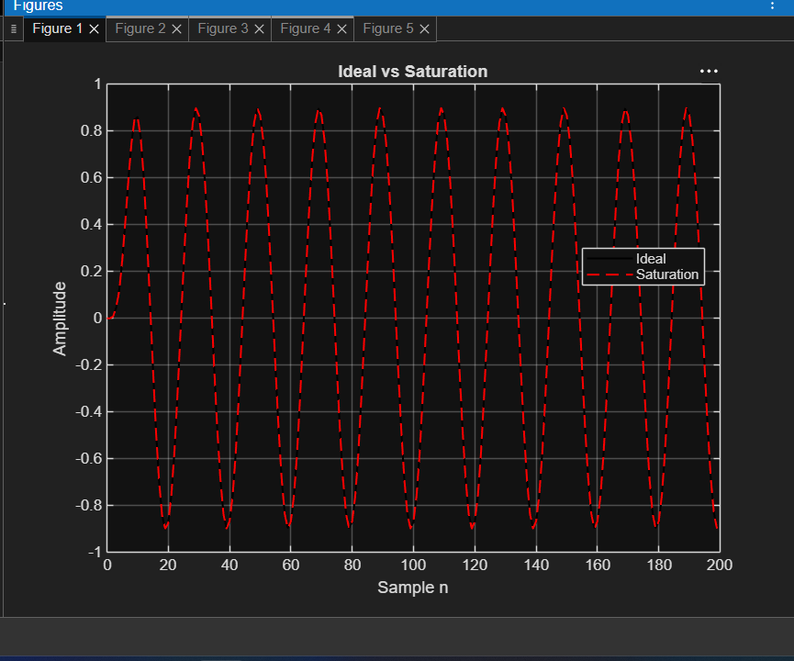
7. Applications
- Fixed-point digital signal processors and embedded systems.
- Audio and communication signal processing.
- Overflow prevention in digital filters.
- Selecting suitable signal scaling and numerical representation.
8. Result
The fixed-point Q1.7 filter output was examined using saturation, wrap-around, and signal scaling. The unscaled signal did not exceed the representable range, and the overflow count was zero. Scaling the input by 0.5 reduced the output peak to approximately 0.453125. The output errors were evaluated using RMSE and the results were plotted.
9. Conclusion
The experiment demonstrated the effects of fixed-point quantization, saturation, wrap-around arithmetic, and signal scaling in digital filters. Signal scaling reduced the output magnitude and helped preserve headroom within the Q1.7 range.
Lokesh A (192512293)
B.E. Electronics and Communication Engineering (ECE)

